**Logical modelling of Car Dealership and Parts**

After my friend Mr.sanjeev Banmala provided me with the requirement analysis of the car dealership and parts company , I tried to model it by building its appropriate ER model.

Some of the possible entities listed by my friend are:

1. Car
2. Customer
3. Salesperson
4. Service
5. Service Ticket
6. Parts
7. Mechanic

**Business Rules**

* A salesperson may sell many cars, but each car is sold by only one salesperson.
* A customer may buy many cars, but each car is bought by only one customer.
* A salesperson writes a single invoice for each car he or she sells.
* A customer gets an invoice for each car he or she buys.
* A customer may come in just to have his or her car serviced; that is, a customer need not buy a car to be classified as a customer.
* When a customer takes one or more cars in for repair or service, one service ticket is written for each car.
* The car dealership maintains a service history for each of the cars serviced. The service records are referenced by the car’s serial number.
* A car brought in for service can be worked on by many mechanics, and each mechanic may work on many cars.
* A car that is serviced may or may not need parts (e.g., adjusting a carburetor or cleaning a fuel injector nozzle does not require providing new parts).

**Entity Relationship Diagram of Car Dealership and Parts**

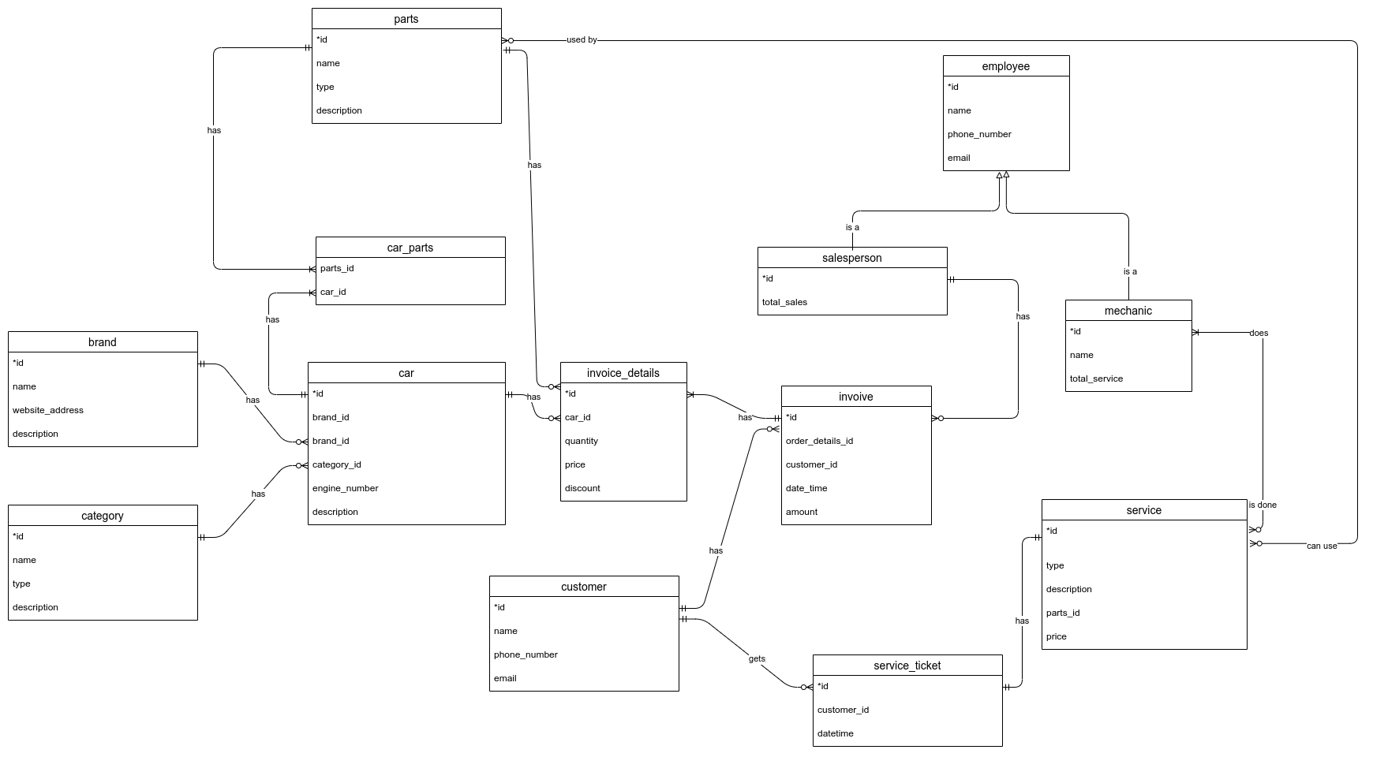

*Fig: ER diagram of Car Dealership and Parts*

**Verification**

As from the beginning I was taking in mind some of the problems like Fan-Trap and Chasm problems , the model I built above is free from it.

Still we can have a Fan-Trap problem if we tried to relate a service_ticket with an invoice.

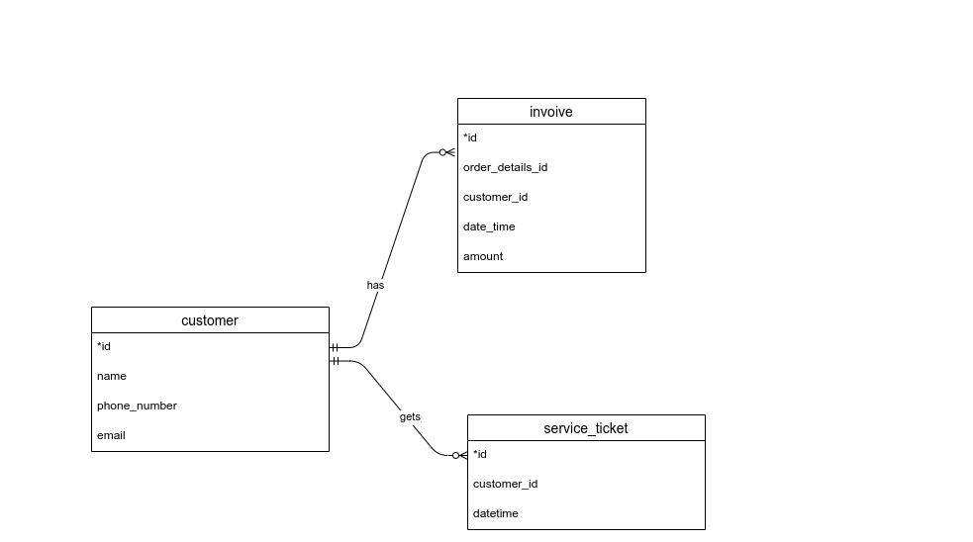

But, does it even make sense .Do we need to relate a service_ticket with the invoice .

We can simply extract the information like a customer with an invoice and a service_ticket is simply a loyal customer which buys the product from the dealer and also does the servicing there.

But if we exactly want to relate the service_ticket with the invoice then , from the invoice we can extract the invoice details and further we can add an attribute like engine_number in the service_ticket to know that the service ticket for the car is bought by the customer from that specific dealer.

**Reference**:

1. Draw.io (for ER diagram)